Ski Trip, Courmayeur, Italy

15th – 23nd February 2020

February ½ term

Dear Parents,

The trip in the academic year 2019-2020 is to Courmayeur, Italy, with Interski. It will take place over the February ½ term holiday.

Courmayeur is a relatively high resort, with an excellent snow record. We are staying in Telecabine Hotel in Dolonne. The accommodation is about 10 mins walk from the main access lift. We will be using the Interski ski lockers on the mountain so all the equipment does not have to be carried back to the hotel every night. From ski hire the lifts radiate out to provide a steady progression of piste difficulty up to the highest run at over 2600m.
The package cost will be £1030 this includes:
- Return executive coach travel
- The equivalent of full board in a hotel which includes hot midday meals in mountain restaurants
- 6-day lift pass with 2 X 2.5hr ski lessons per day
- Optional additional 1.5hrs supervised skiing / boarding with school staff per day
- Comprehensive snowsport insurance
- Hire of snowsport equipment skis, board, boots and poles
- Proficiency test with badges and certificates awarded at the end of the course
- All evening entertainments such as ice skating, bowling, pizza night, etc.

Additional costs will include any spending money (€30-50), skiing / boarding clothing (some students hire @ £35) and gloves, goggles. Also for under 14s it is an Italian legal requirement to wear a helmet (rental cost £12).

Snowboarding
We have previously taken boarders and 'free skied' with them and skiers, after lessons for about 2hrs per day. We have done this without issue for nearly 20 years. It also allows pupils to ski or board with their friends in a supervised environment.
However, there have been some changes to guidance issued to teachers about supervision of pupils on the slopes. In a 'nut shell' a ski qualified teacher can supervise skiers and a boarding qualified teacher can supervise boarders, but unless the teacher is 'double qualified' they can't supervise a mixed group. This has implications if you want to snowboard. We will have to buy some additional instructor time for the boarders - this will be an additional cost for you. Having just spoken to Interski they can supervise you for £35 per person for the week, (1 hour extra slope supervision each day for 5 days). There is also a £40 surcharge for snowboarding for the week anyway, to cover the smaller lesson groups.
To summarise the snowboarders will just get one hour of after lesson, ‘free ski’, with only boarders. All abilities will be in one group for this one hour. The total additional supplement is £75. (£1105 rather than £1030).

If you would like to book a place for your son / daughter please:

- Complete the attached reply slip
- Once we have received the reply slip, we will request a £100 deposit, using ParentPay.
Please note this deposit with which we secure our booking with Interski is non-returnable.

In the past these visits have been very popular and places are allocated on a first come, first served basis. Please note the balance of payment (£1030) is due on 17th October 2019

There will be an information evening for this trip in October/November 2019. You can also contact us at school if you have any further questions.

Yours sincerely,

Mr Gibb/Ms Allison

skitrip@kes.sheffield.sch.uk

KES Students enjoy ‘free ski’ after lessons, with staff in Italy.

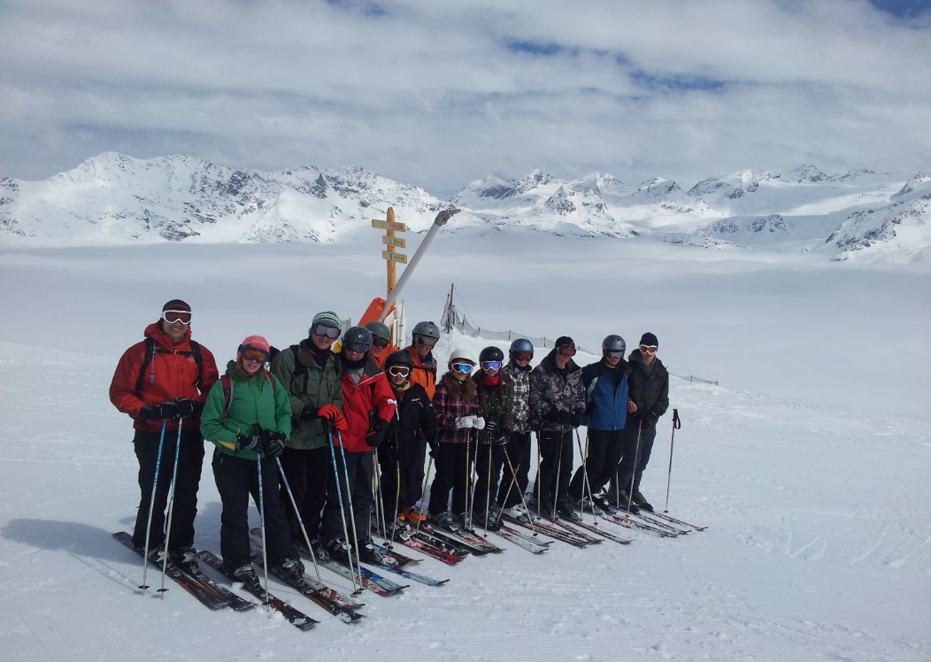
Courmayeur
Probably the most internationally renowned of Interski's three resorts, Courmayeur boasts 100 kms of exciting downhill runs, from easy to challenging. The Baby Bowl is a great beginners area, serviced by its very own (slow moving) button lift. Safe and secure. Ideal for learning. For intermediates, Courmayeur is a 'red run heaven' – loads of wide pistes of varying gradients. Internazionale is fantastic and holds some great snow long into the season. Diretta and Bertollini are the order of the day for the more advanced. They are steep, challenging and seem to change day to day. Brilliant!
Nestling comfortably at the foot of mighty Mont Blanc, Courmayeur is a delightful, old traditional Alpine village, at the heart of which is a maze of interesting, narrow cobbled alleys. Largely traffic- free, it is lined with charming shops. We bet you won’t be able to resist the tempting pastries, delicious cheeses, smoked meats, pizzas and crepes on offer!

Ski-Trip
15th – 23nd February 2020
February ½ term

I give permission for my son / daughter………………………………………….....form………..
to take part in the ski trip at February ½ term in Courmayeur, Italy, with Interski.

I understand the snowsports are hazardous sports and serious injuries can result. Whilst staff accompanying the trip will take all reasonable care of my son/daughter, I understand that they cannot necessarily be held responsible in the event of an accident.

Parents name ………………………………………….. Signature ………………..

Date ………………
Address ………………………………………………….

……………………………………………………

………………………………………………….

Post code ………………………………………………Telephone. ………………………..

Parent’s e-mail………………………………………………………………………………….

Student’s e-mail ………………………………………………………………………………..

Please return this form in an envelope marked

“Ski Trip – Feb 2020 Mr Gibb/Ms Allison”

@ Upper School (if you are at Lower School please hand into school office).

Thanks.

